**Member Contribution – Team Annex**

**Roles**

Brian Olsen

1. Developed Interview Script
2. Changes to prototype
3. Interview 1: Human Computer
4. Interview 2: Interviewer
5. Interview 3: Note Taker

Joshua Koehn

1. Member Contributions
2. Compiled all interview notes and the ideas gleaned from each interview
3. Changes to prototype
4. Interview 1: Note Taker
5. Interview 2: Human Computer
6. Interview 3: Interviewer

Richard Blotevogel

1. Took lead on designing user interfaces
2. Changes to prototype
3. Interview 1: Interviewer
4. Interview 2: Note Taker
5. Interview 3: Human Computer

**Team Minutes**

Team Meeting 1 3-11-13 2:45pm – 3:15pm

Discussed preliminary design ideas. Made calls for and scheduled interviews.

Team Meeting 2 3-17-13 2:00pm – 5:00pm

Met at school to print prototype and discussed/made changes to them. Created interview script.

Interview 1 3-18-13 8:00am – 9:00am

Student: Cody Weber Interviewer: Richard Blotevogel

Note Taker: Joshua Koehn Human Computer: Brian Olsen

We met about 30 minutes before the interview to make sure that everything was ready.

Stayed afterward to pull the video off of the computer.

Team Meeting 3 3-18-13 8:30am – 10:00pm

Met to discuss/make changes to prototype and interview script before the next interview.

Interview 2 3-18-13 10:00am – 11:00am

Student: Thomas Bauer Interviewer: Brian Olsen

Note Taker: Richard Blotevogel Human Computer: Joshua Koehn

Stayed afterward to pull the video off of the computer.

NOTE: Originally had interview 3 scheduled for 8am on 3-20-13 with Rion Kolosieke, but he did not show

up. We found an alternate student to interview at about 10:30.

Team Meeting 4 3-20-13 8:00am - 10:30am

We finished all the documentation (except from the third interview) for phase 3.

` We also began to brainstorm on our plan for phase 4.

Our plan for how the Direction GUI will look:

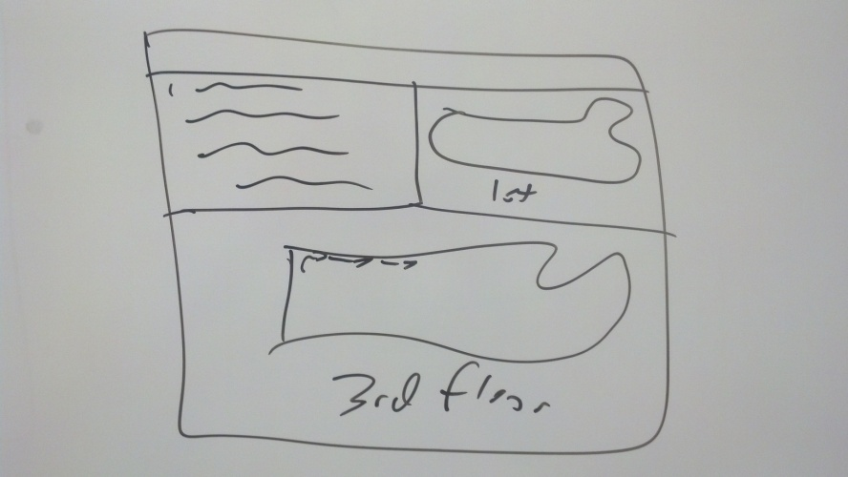

Interview 3 3-20-13 10:30am - 11:00am

Student: Paul Pinneo Interviewer: Joshua Koehn

Note Taker: Brian Olsen Human Computer: Richard Blotevogel

Stayed afterward to pull the video off of the computer and get everything ready to submit.